**CSA1313- THEORY OF COMPUTATION**

G.Chandu Manikanta

192211965

1. Design PDA using simulator to accept the input string anbn

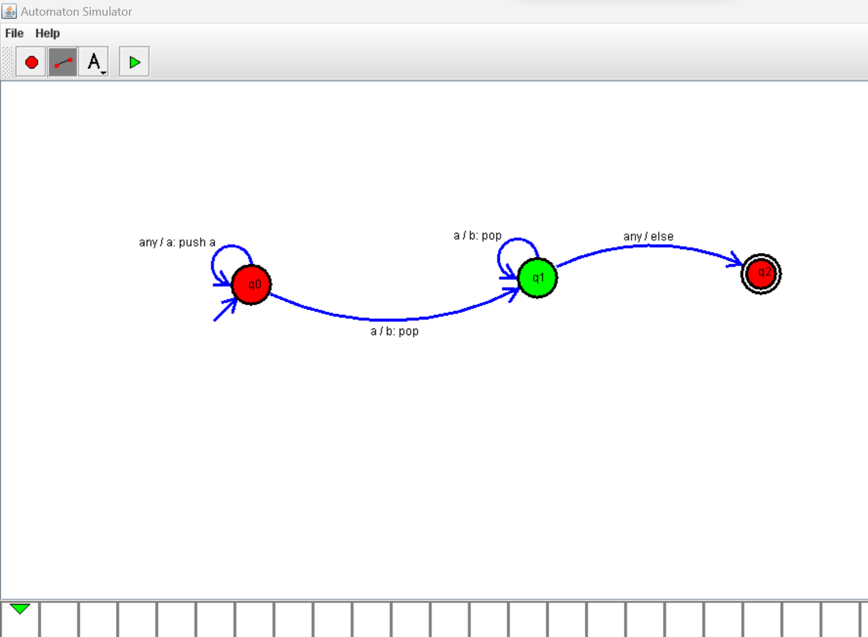

1. Design PDA using simulator to accept the input string anb2n

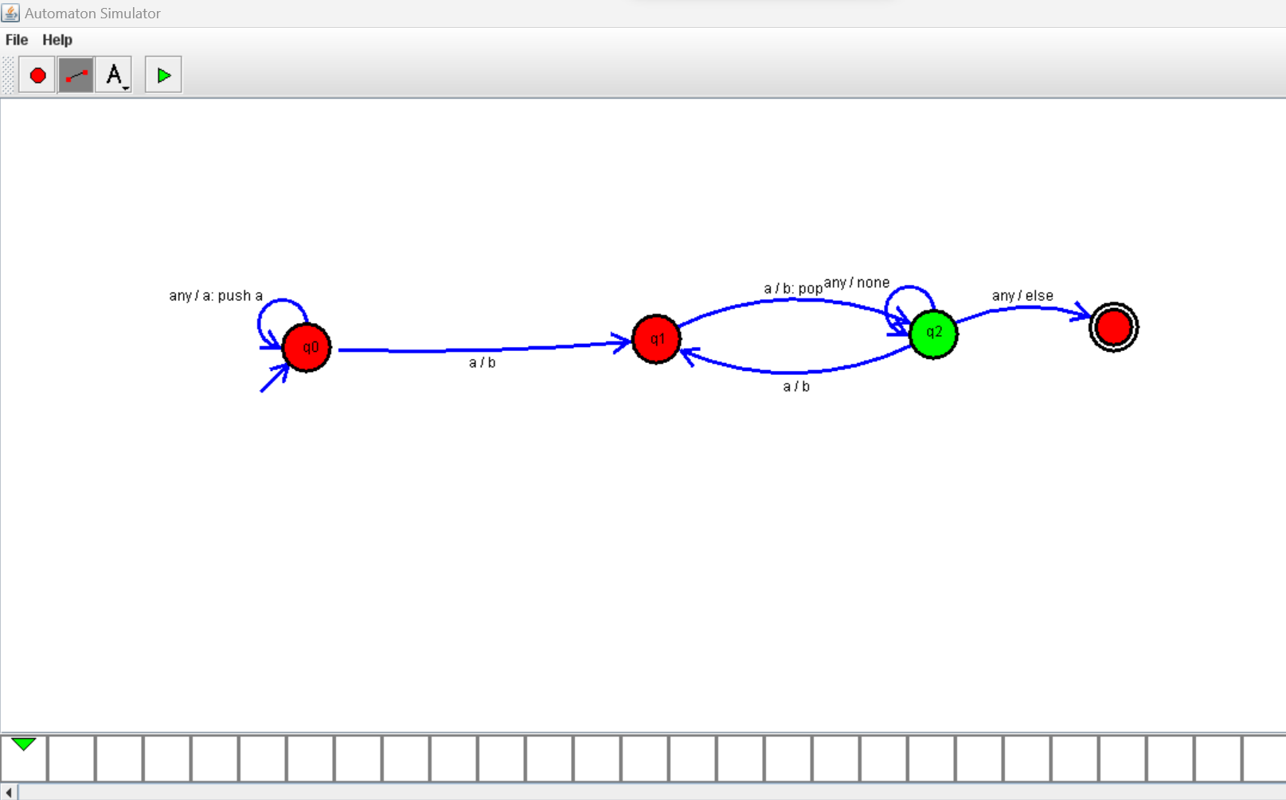

1. Design PDA using simulator to accept the input string aabb

